CSE 335 Phase 1

The Pawfect Match App

**Use case diagram: (Made in Astah)**

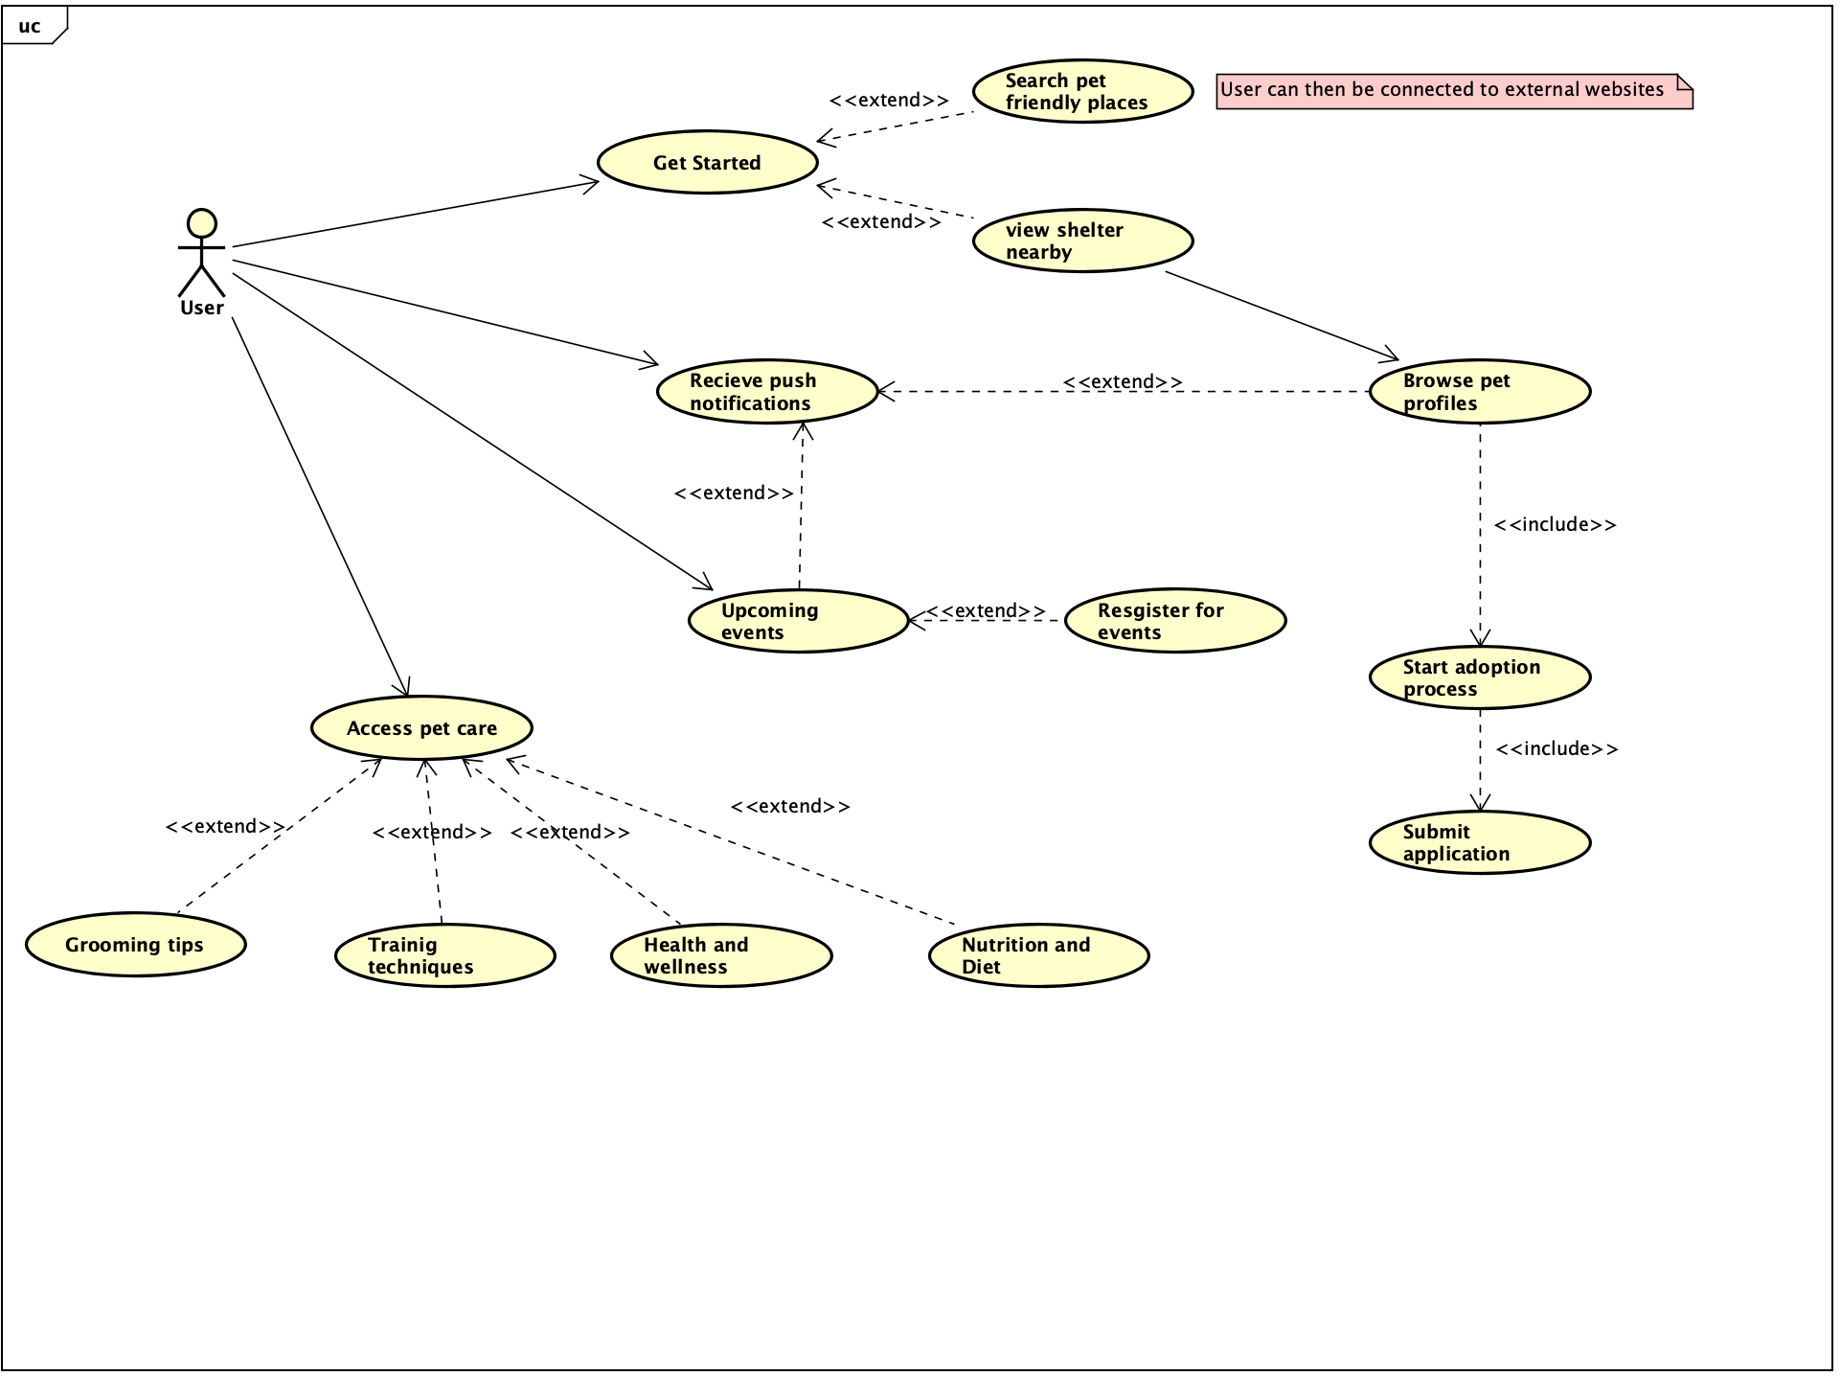

**Class diagram: (Made in Astah)**

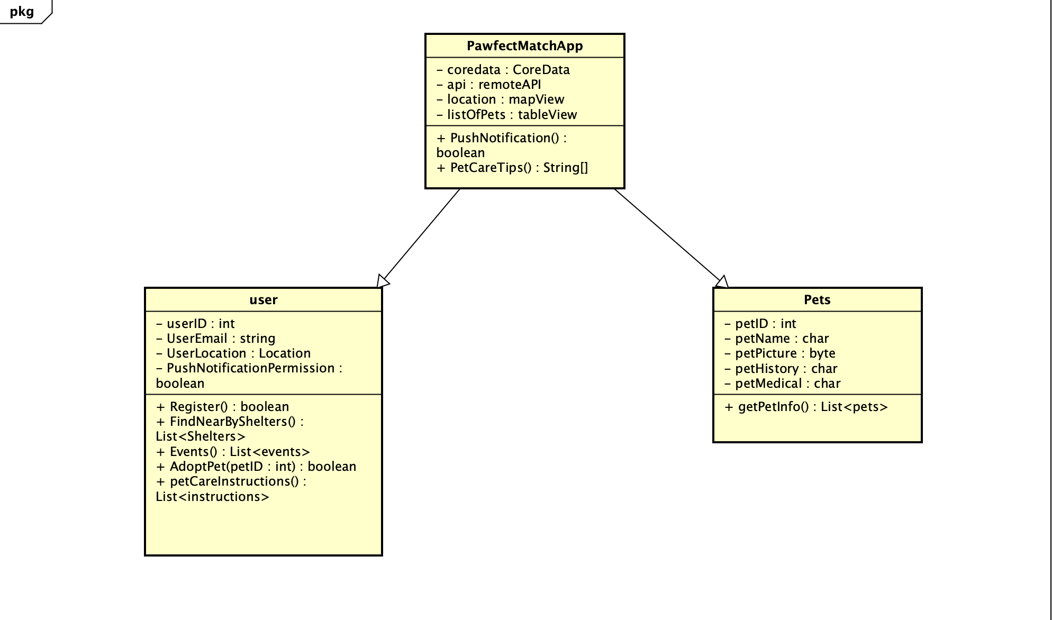

**MVVM diagram:**

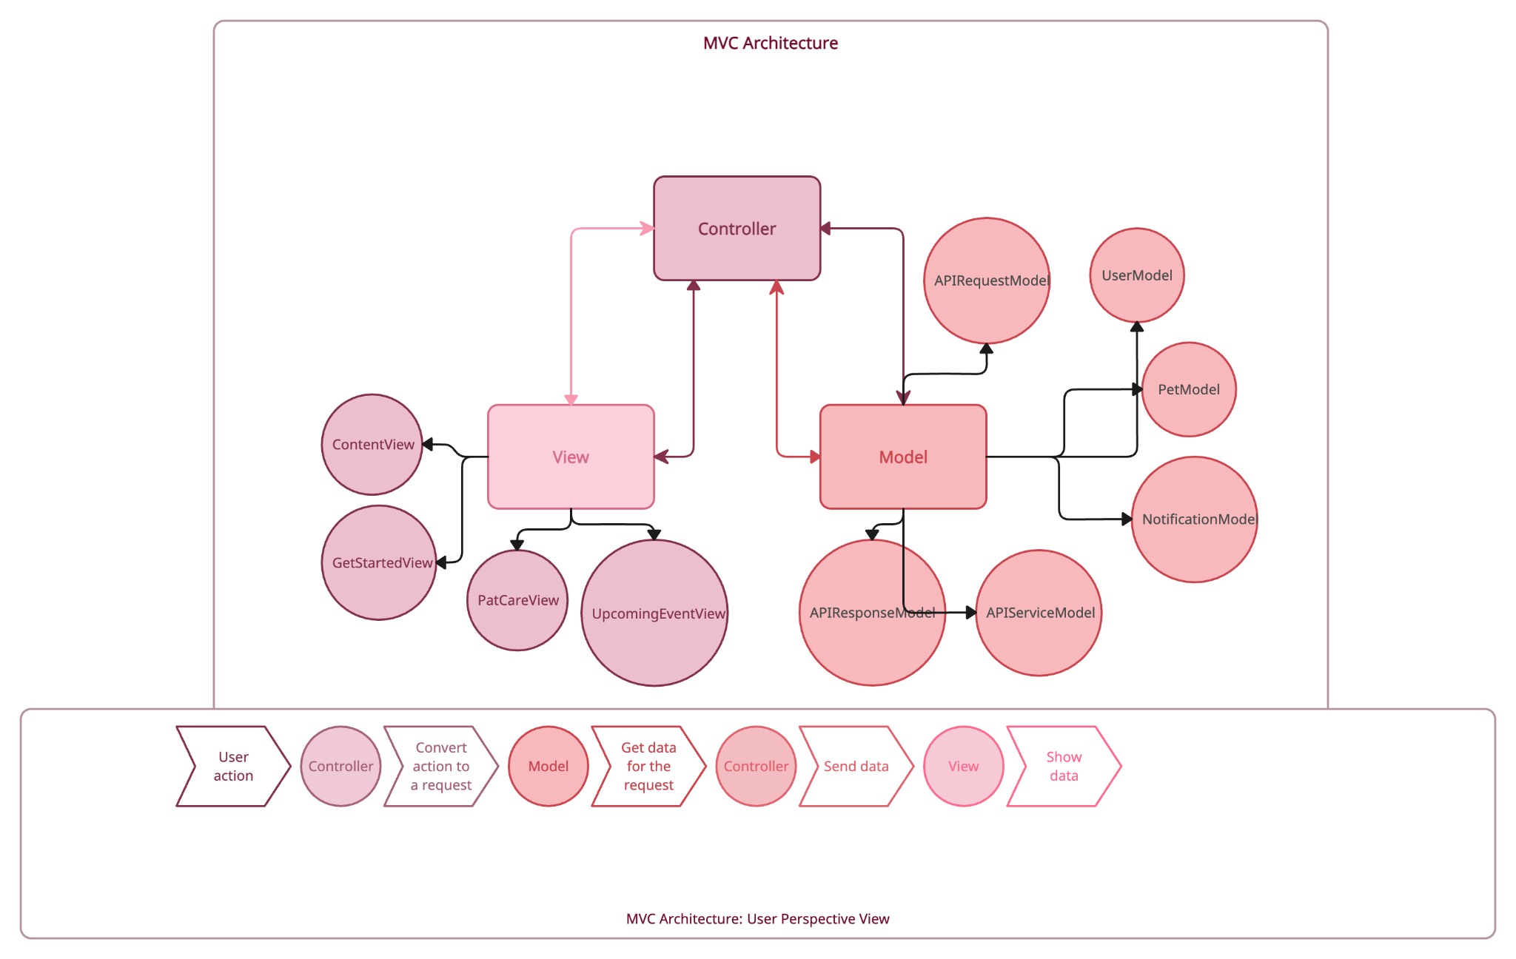

**UI Walkthrough:**

This is the main homepage.

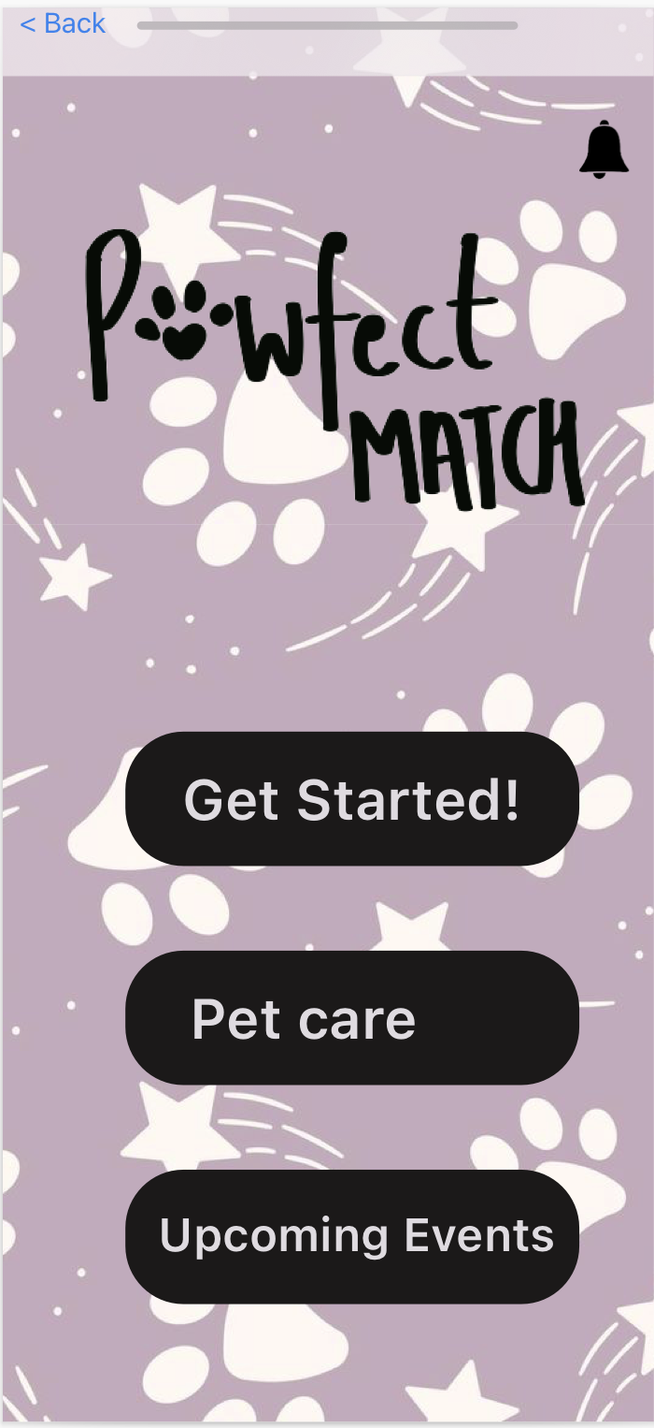

When the user clicks on the notification icon on the home page, it asks for notification permission to get notified about the adoption events and new pet profiles. If the user clicks ‘ok’, they get the notification on the top navigation bar.

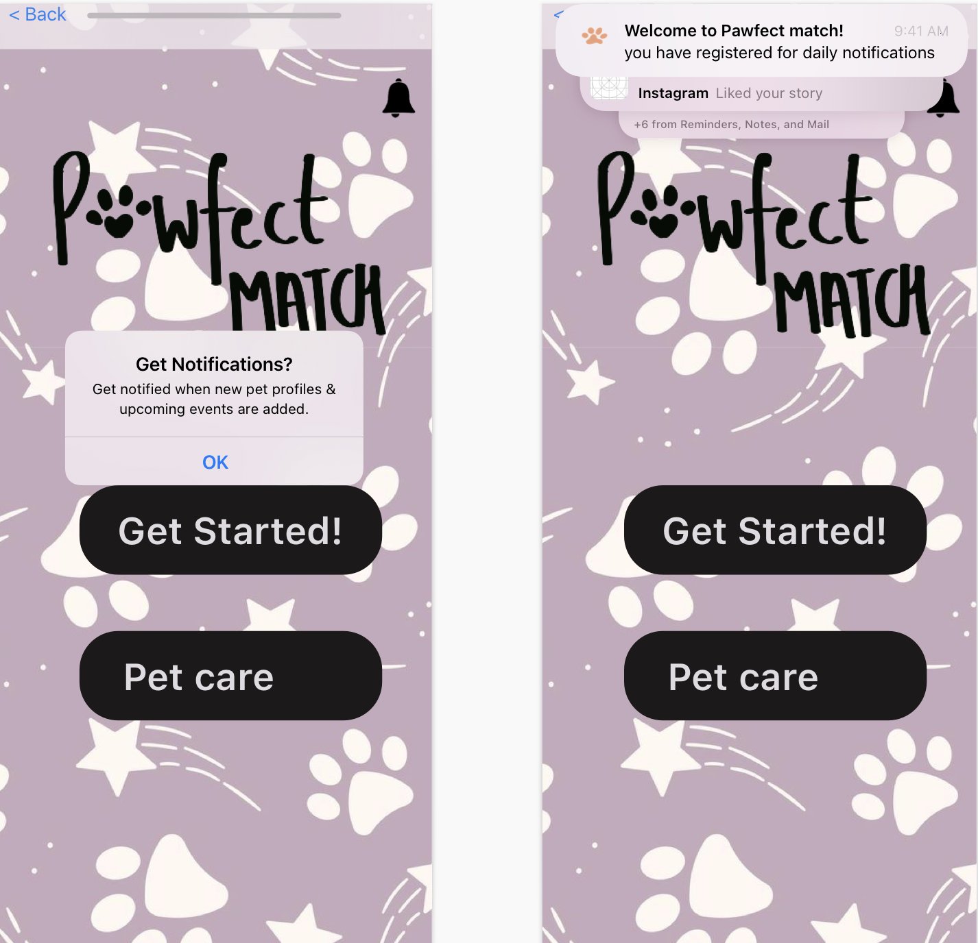

When the user searches for ‘pet-friendly places near me’ or ‘pet friendly’, it lists pet-friendly places near them in a table view. When a place is selected, it leads the user to an external website.

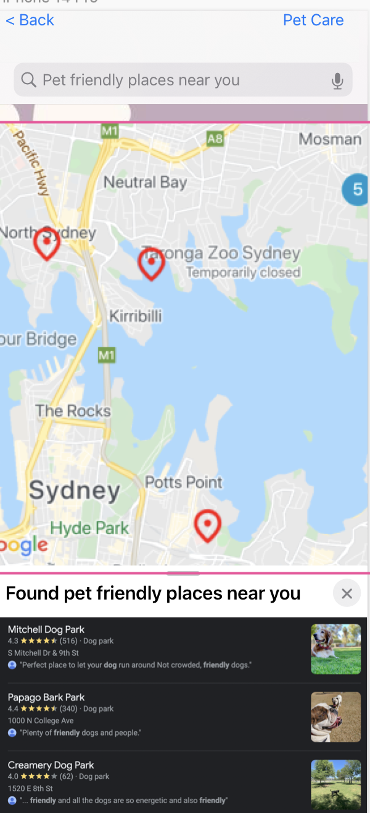

When the user clicks ‘Get started’ it takes them to a map locator page. They can search for adoption shelters near them or pet-friendly places near them.

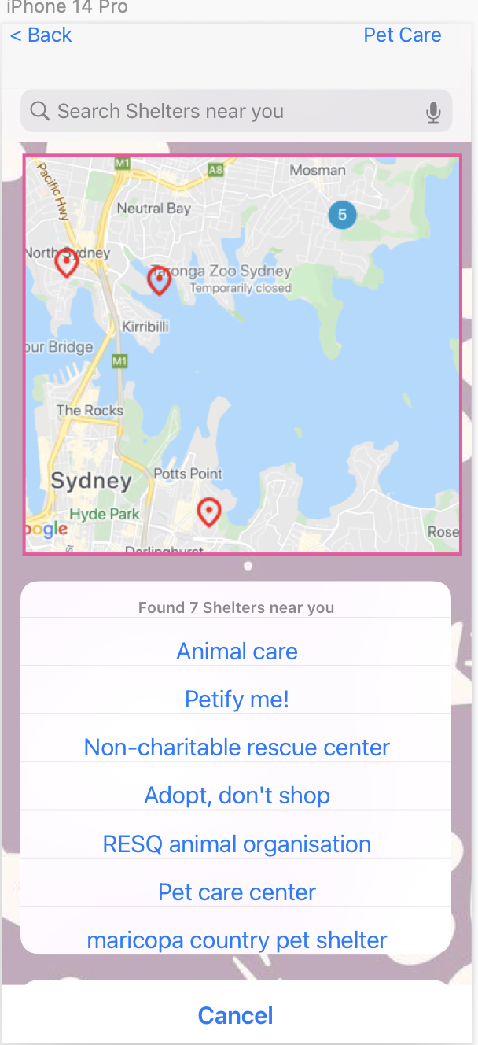

When the user clicks on any of the shelters in the table view, it takes them to a page where they can browse pets but clicking on the side arrow button. The basic pet information is provided on this page. If the user wants to know more about the pet, they should click on the pet image.

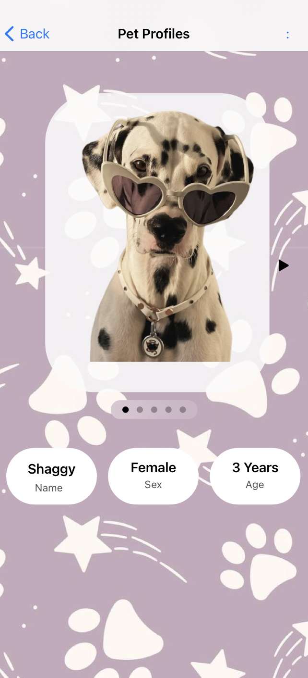

When the user clicks on the pet image, they are directed to the “about me” page where pet information and background are displayed.

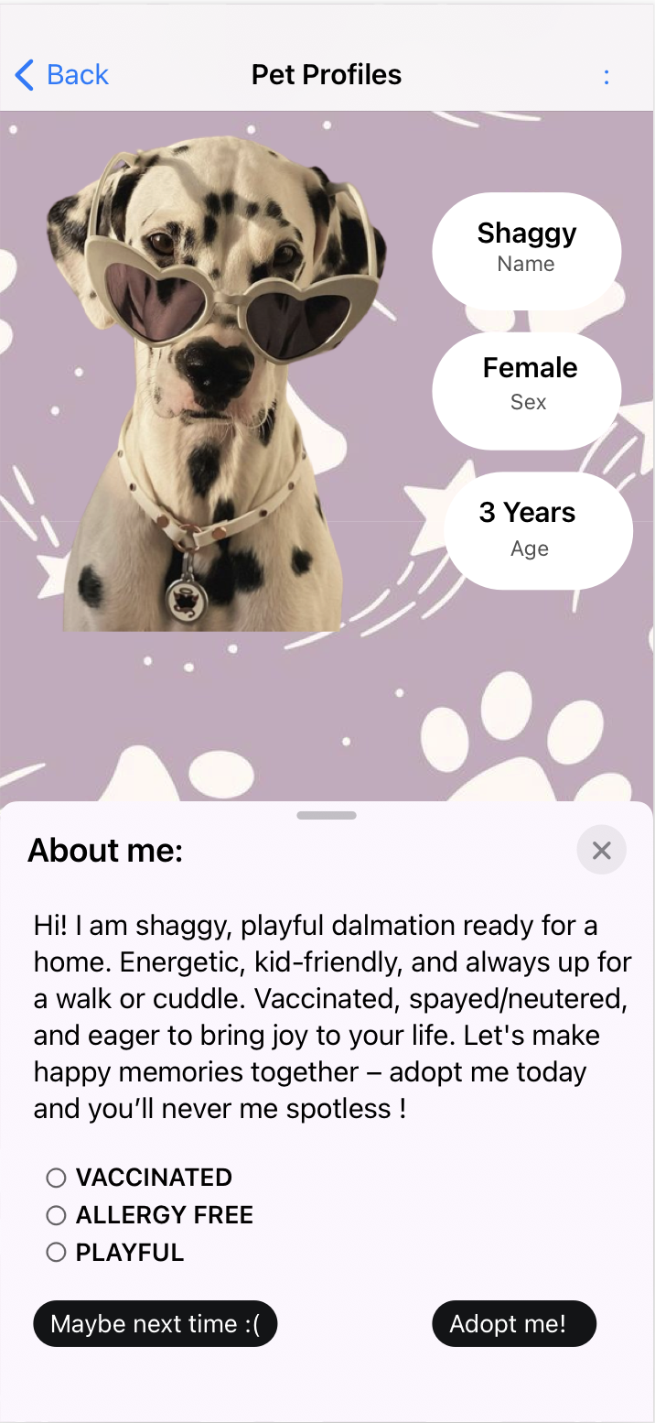

When the user clicks on the ‘maybe next time’ button, they are directed back to the pet browsing page.

When the user clicks on the ‘adopt me’ button, they are directed to the adoption process page.

When the user clicks on the side button to swipe more pet options, they are shown with a different option.

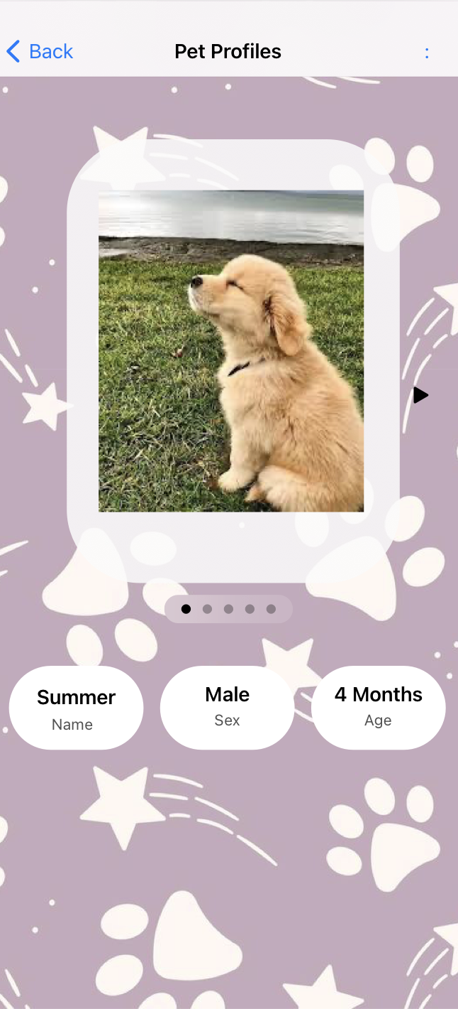

When the user clicks on the pet image, it takes them to the pet information page.

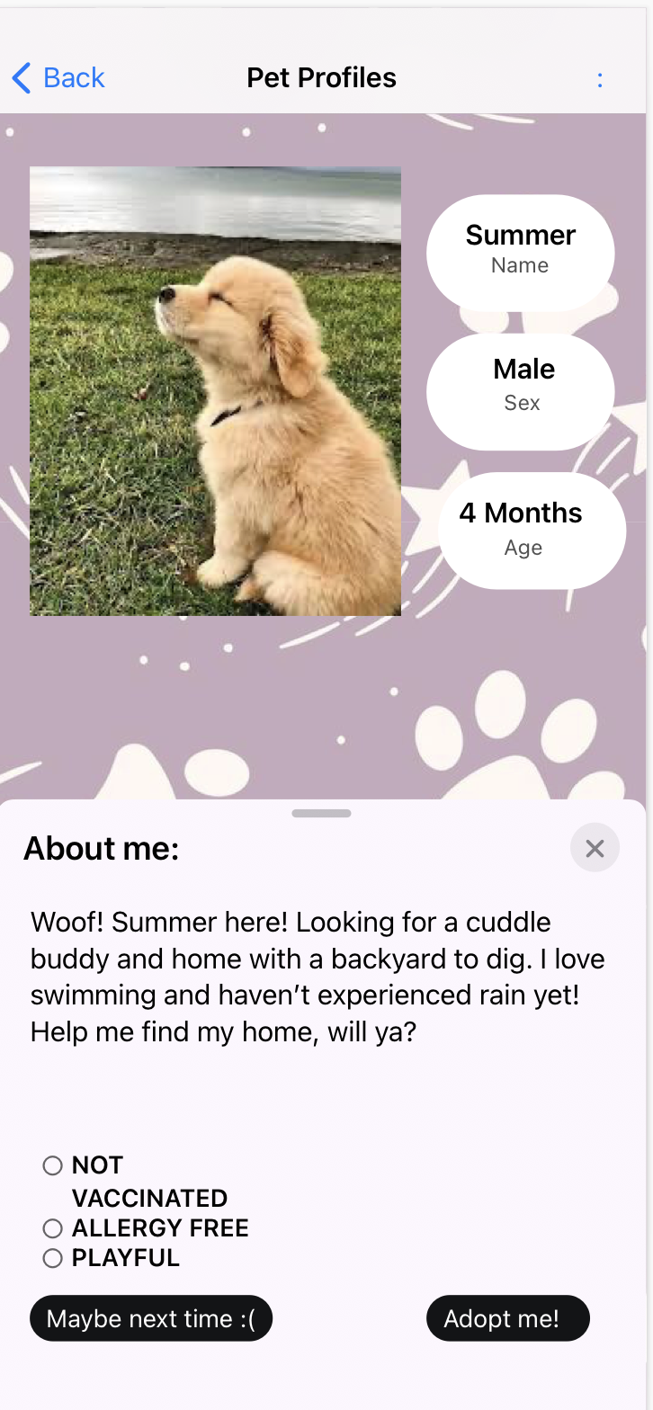

When the user clicks on the Adopt Me button, it takes them to the adoption process page where they have to fill out an adoption application form.

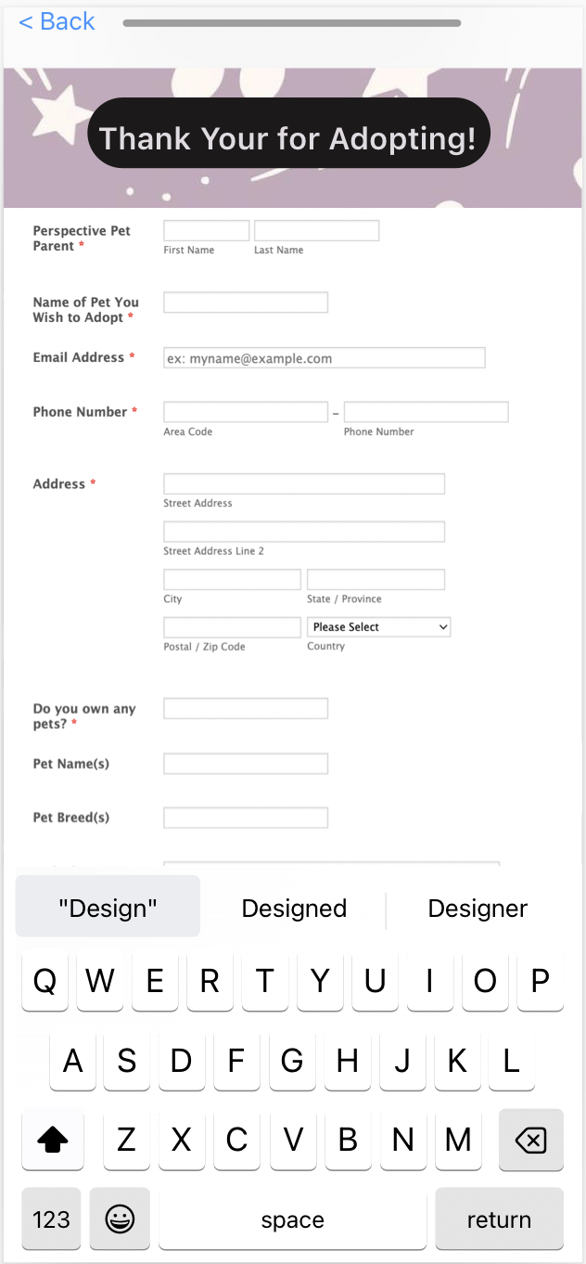

When the user clicks on ‘Upcoming events’ on the homepage, it leads them to 3 different UI pages. It asked the user to pick a date and time that works best for them. Then a list of events is displayed and when the user clicks on any one of them, it provides event information and options for the user to enter email, phone number, and register for the event. The user also gets a notification when they are registered for the event.

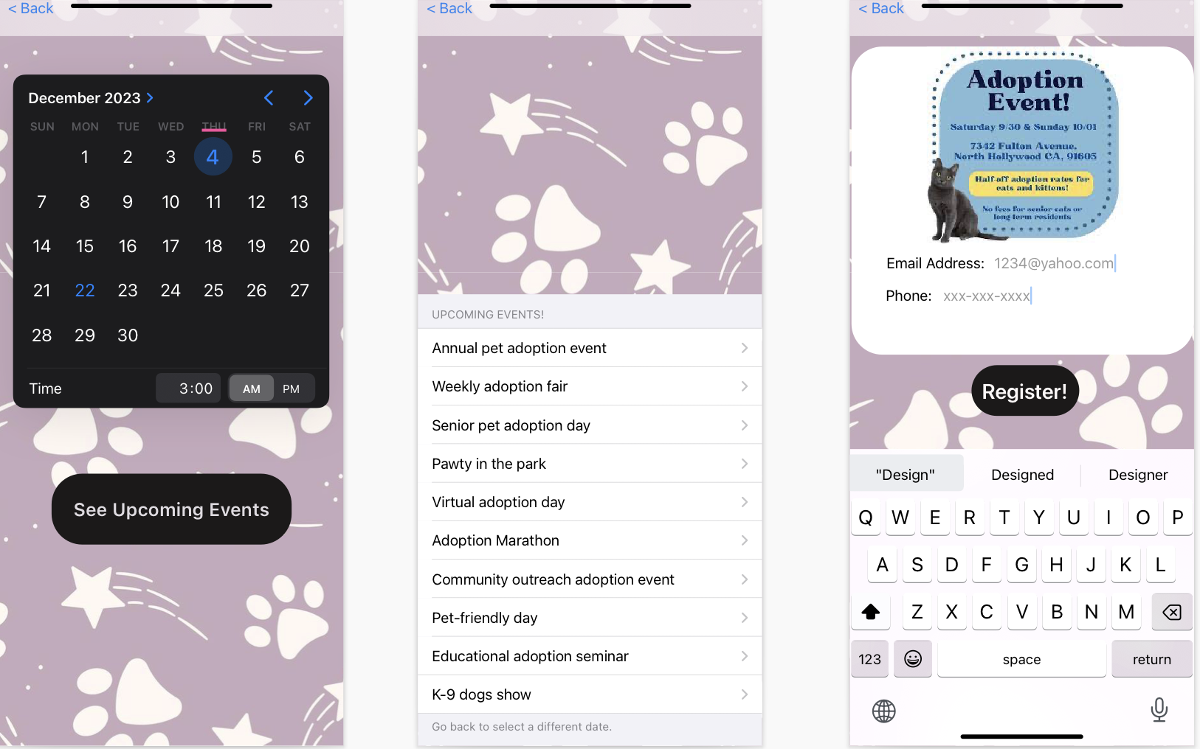

When the user clicks on the ‘pet care’ option on the homepage, they are provided with multiple options and application customer care contact information.

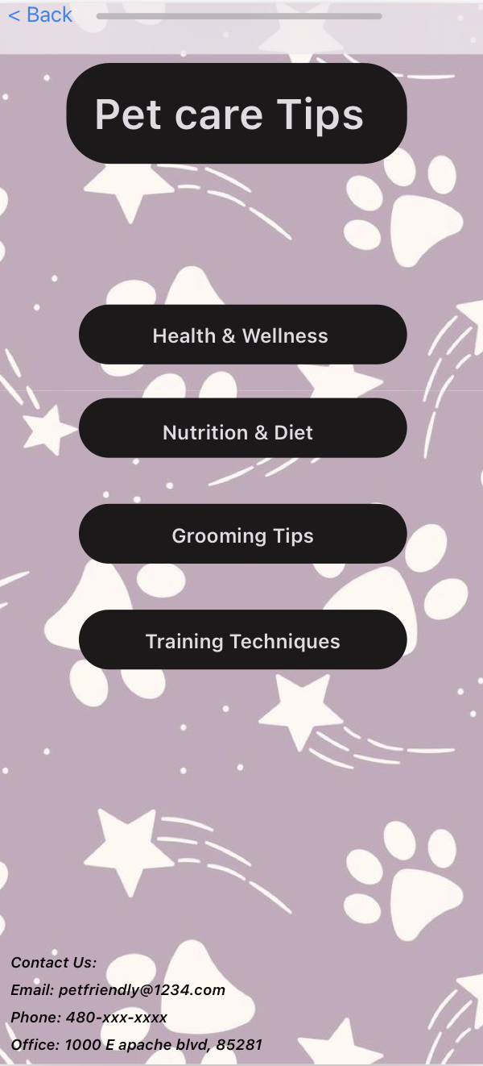

When the user clicks on any of the options, they are provided with relevant information.

